**Spring Boot Course – Chad Darby**

Spring Boot runs on top of Spring Framework, it uses Spring framework underneath along with other Spring Projects Like Spring Web, Spring MVC, Spring Rest API like these there are many spring projects which we can use to create a Spring Boot App

* Minimizes manual configurations
* Handles the dependencies (JARs) using MAVEN or GRADLE
* Comes with Embedded Server (TOMCAT, JETTY etc.) can be run standalone because of this.

MYAPP.JAR

TOMCAT SERVER

CODE

Run Spring Boot Application in CMD

***java -jar myapp.jar***

How to create Starter Spring Boot Application – <https://start.spring.io>

* Here you can select the java version, build tool (Gradle or Maven)
* Add dependencies
* Add the project and package names

Creating Simple Rest Controller in Spring Boot (Hello world App)

@RestController  
public class MyController {  
 @RequestMapping("helloworld")  
 public String helloWorld() {  
 return "Hello, World!";  
 }  
}

There are many spring projects which we can use in our application some of the examples being Spring Web, Spring Data JPA, Spring Security, Spring MVC etc.

We can learn more about spring project here <https://spring.io/projects>

**What is Maven?**

Maven is a project management tool, it manages dependencies.

Dependencies of our application requires several JAR files which need to be downloaded from the internet Central MAVEN repository, this is handled by Maven project management tool, Gradle is also same as Maven.

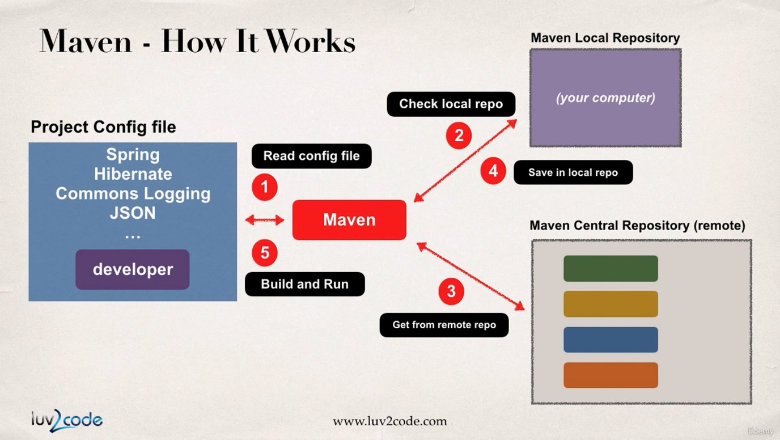

Working of MAVEN, it will read config file first and checks local maven repo, and If required JARs are not found in local it will get them from Remote Maven central Repository.

Maven will build and handle your app

Maven will add class paths

Based on Config file Maven will add JAR files

**MAVEN Concepts**

**groupId** – name of company (com.google)

**artifactId** – name of the project (maps)

**version** - version of the project (1.2.2) (com.google.maps – 1.2.2)

**Adding Dependencies in pom.xml file**

<dependencies>

<dependency>

<groupId></groupId>

<artifactId></artifactId>

<version></version>

</dependency>

…

</dependencies>

You will get this in MVN Central website, and reading this config file Maven will build your app by importing required JARs

**Spring Boot project structure**

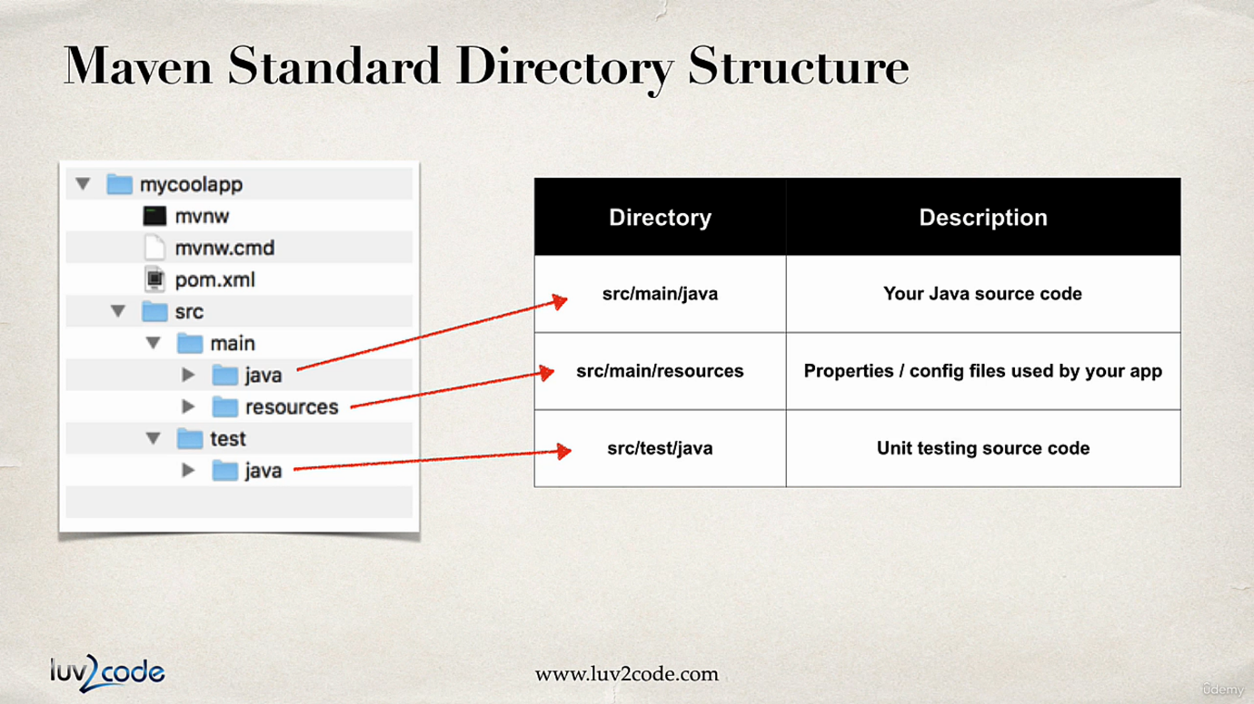

**mvnw.cmd(win) and mvnw (linux/mac)** are maven wrapper files which are used to automatically download the correct version of maven and run the maven for the application.

**pom.xml** is used to add dependencies and plugins required for the project application.

**application.properties** : we can add the properties for application in this file

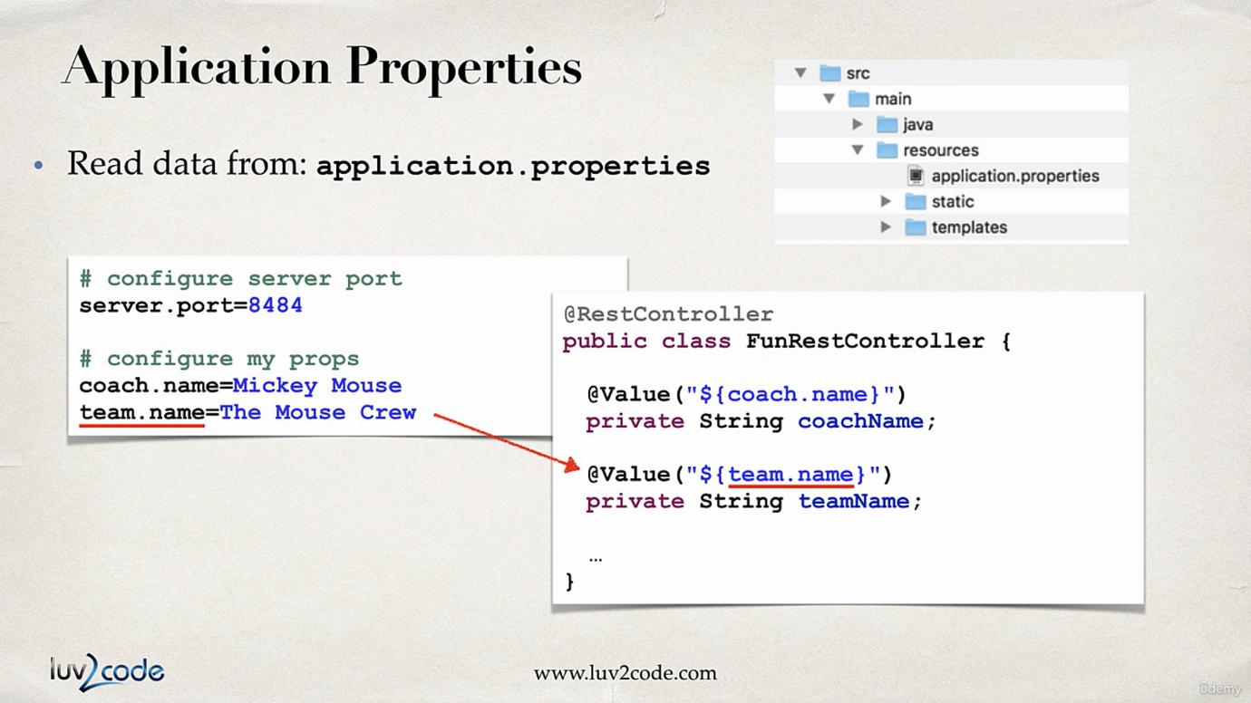

**Spring boot starters:** A dependency which is a collection of other dependencies which are bare minimum requirement to build application.

For e.g. **spring-boot-starter-web**, this contains -> Spring Web, Spring Web MVC, Hibernate-validator, json, Tomcat. (Add Spring Web in Spring initializer)

<https://www.javatpoint.com/spring-boot-starters>

**Spring boot starter parent:** These are maven defaults, this contains default compiler version, UTF-8 source encoding, others…

In <properties> it contains java.version which we are using for the project

<plugins> is used to configure application to run in command line using a command *mvn spring-boot:run*

**Spring Boot Devtools:** By using this dependency we no need to restart the application after every change, whenever we save the changes to file the spring app automatically restarts.

Dependency - **spring-boot-devtools**

IntelliJ configuration of Devtools:

Settings>Build, Execution, Deployment>Compiler -> Build project automatically

Advanced settings > allow auto-make

**Spring Boot Actuator:**

Exposes endpoints to monitor and manage our application.

It is like a Devops functionality

Simply add Dependency to your pom file

Dependency - **spring-boot-starter-actuator**

Endpoints

* **actuator/health** – this gives the status of application – UP/DOWN, By default only this endpoint is exposed
* **actuator/info** – this gives information about our application and we need to configure this by default it will give empty. And to expose this endpoint we need to add this in application.properties file.

#Actuator config  
management.endpoints.web.exposure.include=health, info  
#using =* will expose all endpoints

#management.endpoints.web.exposure.exclude=info,mappings like this we can exclude endpoints from exposure  
management.info.env.enabled=true

# /info setup  
info.app.name=Hello world  
info.app.version=1.0.0  
info.author=shivaraj

* **actuator/auditevents** – audit events for application
* **actuator/beans** – gives all the beans used in application
* **actuator/mappings** – gives all the mappings used in application.
* **/actuator** – we will get all actuator endpoints.

[Full list of actuator endpoints](https://docs.spring.io/spring-boot/reference/actuator/endpoints.html#page-title)

Secure actuator endpoints using Spring security

Add spring-boot-starter-security and then username is user by default and in terminal we will get default password

We can set custom user by using

#spring security user config  
spring.security.user.name=shivu  
spring.security.user.password=shivu

**Running Spring boot application from command line**

We can run easily because there is embedded server inside our app

* Using **java -jar**1. First open cmd in working directory of application  
  2. Run **mvnw package** (or ./mvnw package) – this will create a jar in /target

3. Run **java -jar target/myapp.jar**

* Using **Spring Maven Plugin**1. First open cmd in working directory of application  
  2. Run **mvnw package** (or ./mvnw package) – this will create a jar in /target

3. Run **mvnw spring-boot:run** (or ./mvnw spring-boot:run)

**Custom Application Properties and Injecting them using @Value()**

We can define custom properties for application in application.properties file

And we can use them in any bean/class using @Value annotation

File: application.properties

#Define custom properties  
company.name=clarivate  
company.employee=shivaraj

File: MyController.java

@RestController  
public class MyController {  
 @Value("${company.name}")  
 private String companyName;  
 @Value("${company.employee}")  
 private String employeeName;  
 @RequestMapping("helloworld")  
 public String helloWorld() {  
 return "Hello, " + employeeName + " from " + companyName;  
 }  
}

**Spring application properties**

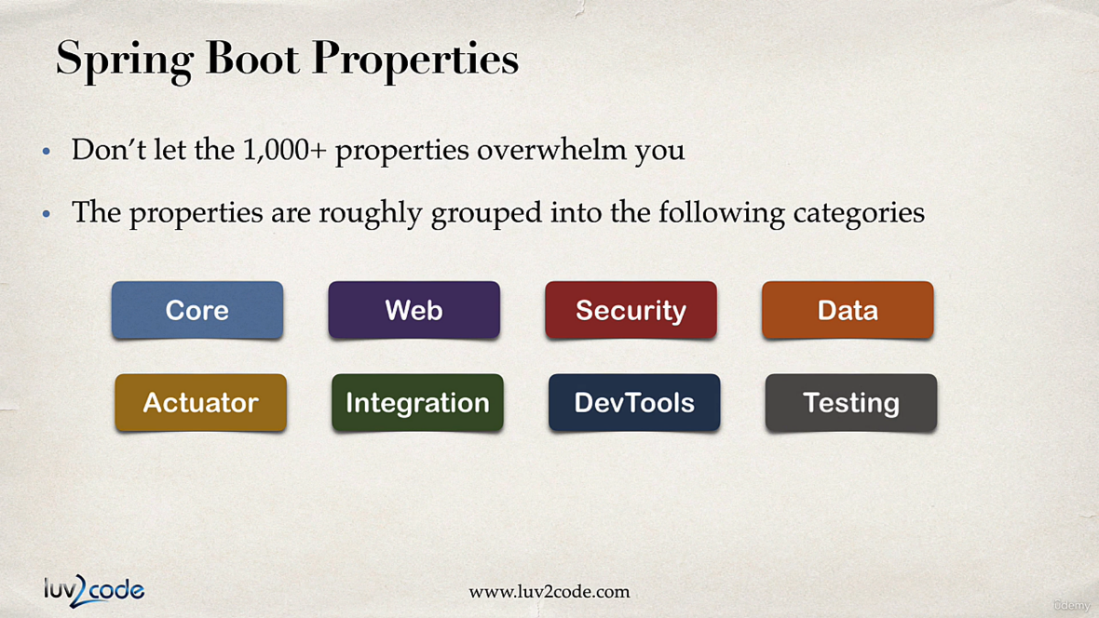

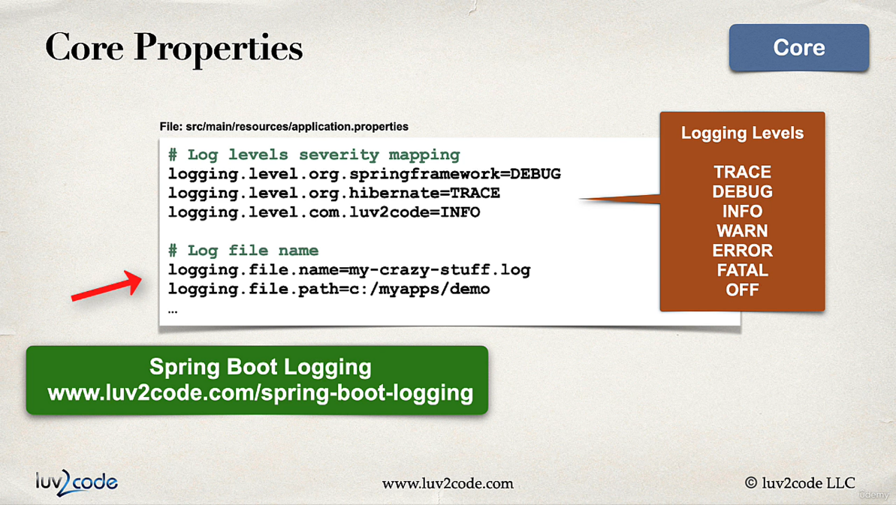

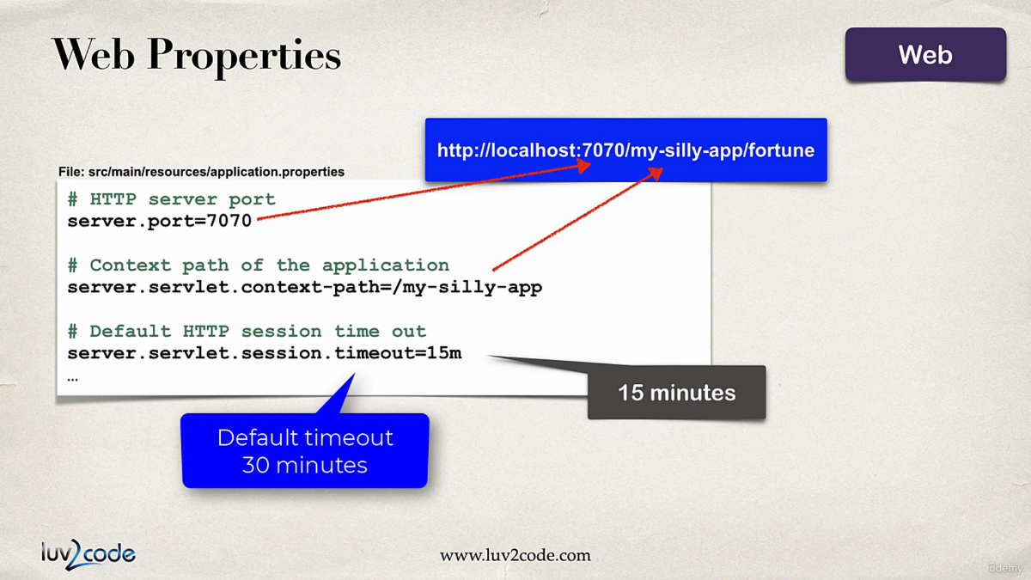

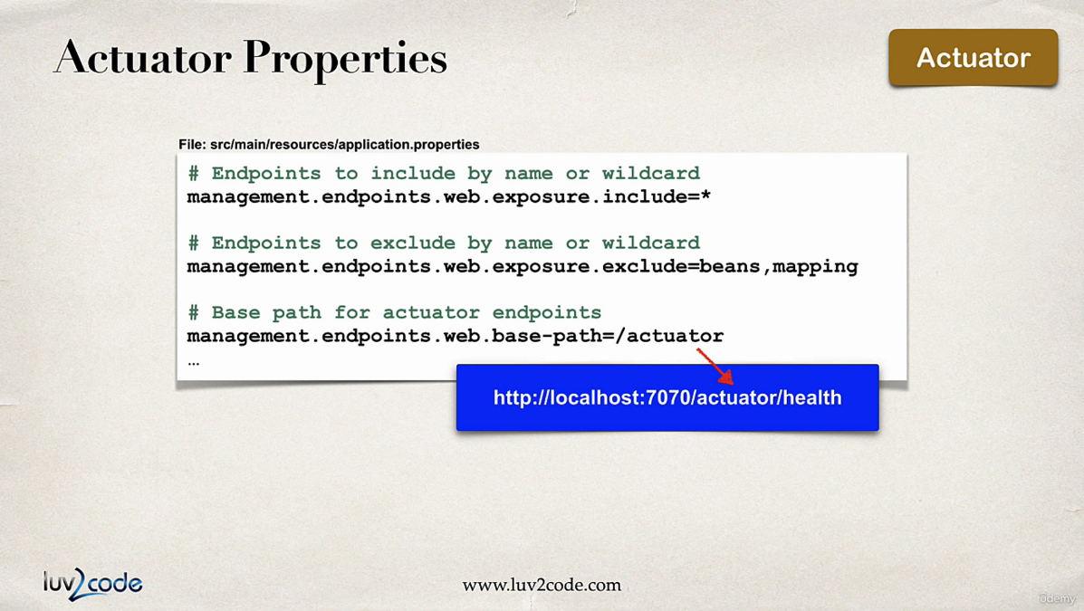

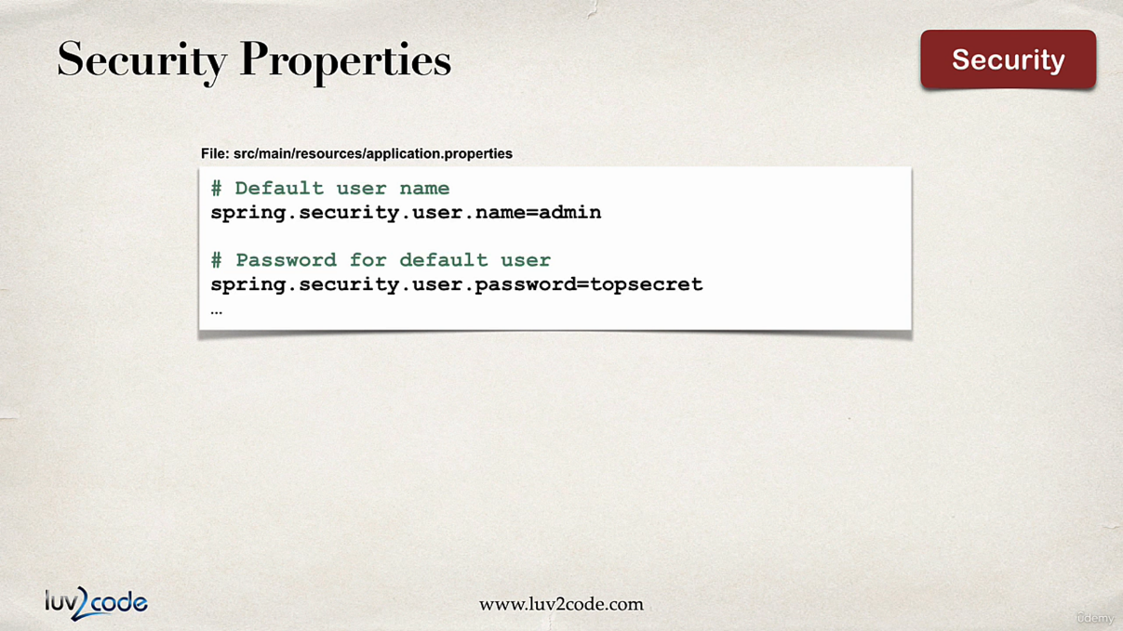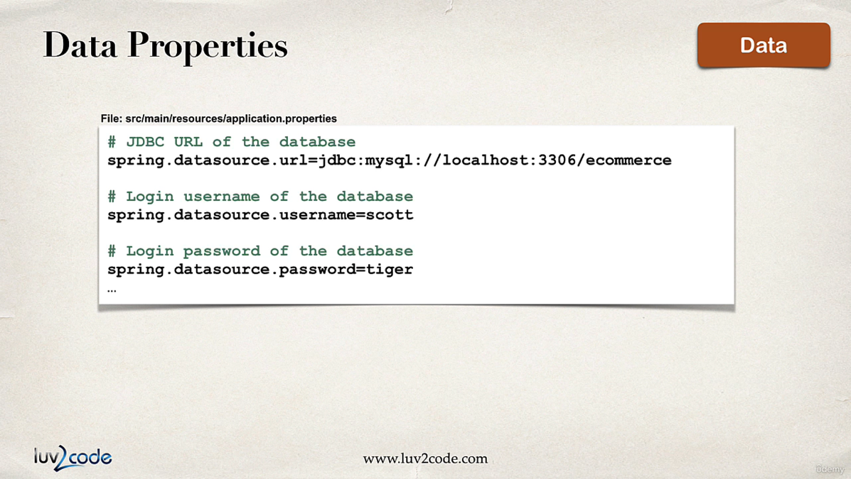

[**List of common properties**](https://docs.spring.io/spring-boot/appendix/application-properties/index.html)

**Spring Core**

**Inversion of Control:** Traditionally in Java Applications we create the objects of the class and inside that class if we need any other class we need to create the object of that class, we use to do this using **new** keyword, so in this approach the creation and managing the object of dependencies was taken care by developer

For e.g.,

public class Vehicle {  
 private Engine engine;  
   
 public void startVehicle() {  
 engine = new Engine();  
 engine.startEngine();  
 }  
}

Here Vehicle class requires the object of Engine class to run, hence we created It using **new** keyword.

In this way the problem is if there are many classes it will be hectic for programmer to manage everything.

Hence, we use **Inversion of control**, where when we create a object of Vehicle class, it automatically creates/invokes the objects of it dependency classes i.e. Engine in this case

Control is now with spring instead of programmer, so we call **Inversion of Control.**

**Dependency Injection:**

Injecting the object into the class or interface which are dependent on that is called dependency injection

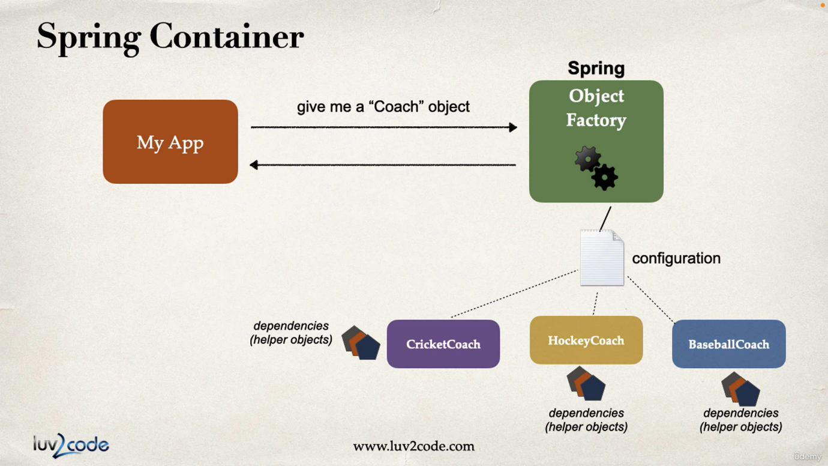

There are 3 types of Dependency Injection:

* Field injection
* Constructor injection (Recommended by Spring.io)
* Setter injection

**Autowiring:** When we Autowire a dependency class inside dependent class/interface, it automatically invokes the object of dependency class for the use of dependent class/interface. This can be done using **@Autowire** annotation

**Field injection**

Autowiring the dependency class at the declaration of that field.

**Constructor injection**

Autowiring the dependency class at the constructor.

**Setter injection**

Autowiring the dependency class at the setter method of that field.

**@Component –** This annotation marks the class as spring bean, bean is a java class that is managed by Spring. And this annotation marks the bean available for Dependency Injection. We can give names to beans using **@Component(“name”)**

**Component scanning**

By Default @SpringApplication implements @ComponentScan annotation, this allows spring to scan through the package and sub packages of the main application class where @SpringApplication is added.

This will scan for the beans, required for Dependency injection.

If we have some beans outside of current package we can mention them in @SpringAppliction( scanBasePackages = {…packages})

In our example

@SpringBootApplication(  
 scanBasePackages = {  
 "com.spring.boot.course.spring_di", //have to mention this also!! or else it will not scan this package.  
 "component.scan.test"  
 }  
)  
public class HelloWorldApplication {  
  
 public static void main(String[] args) {  
 SpringApplication.*run*(HelloWorldApplication.class, args);  
 }  
  
}

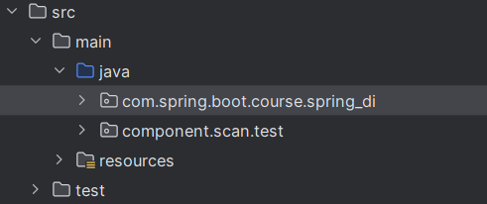

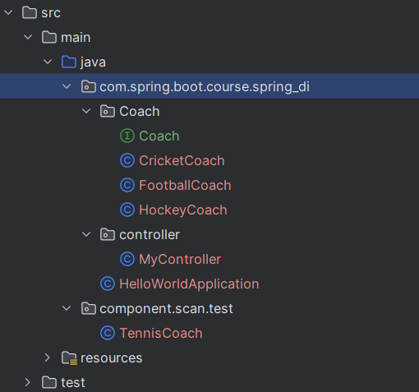

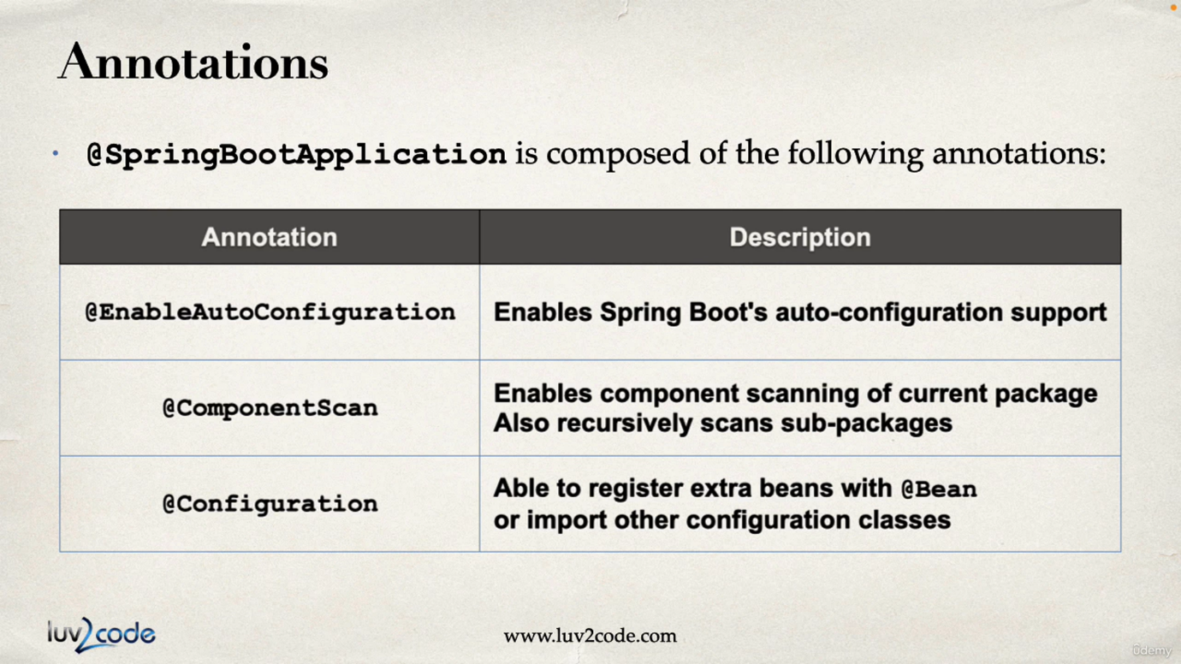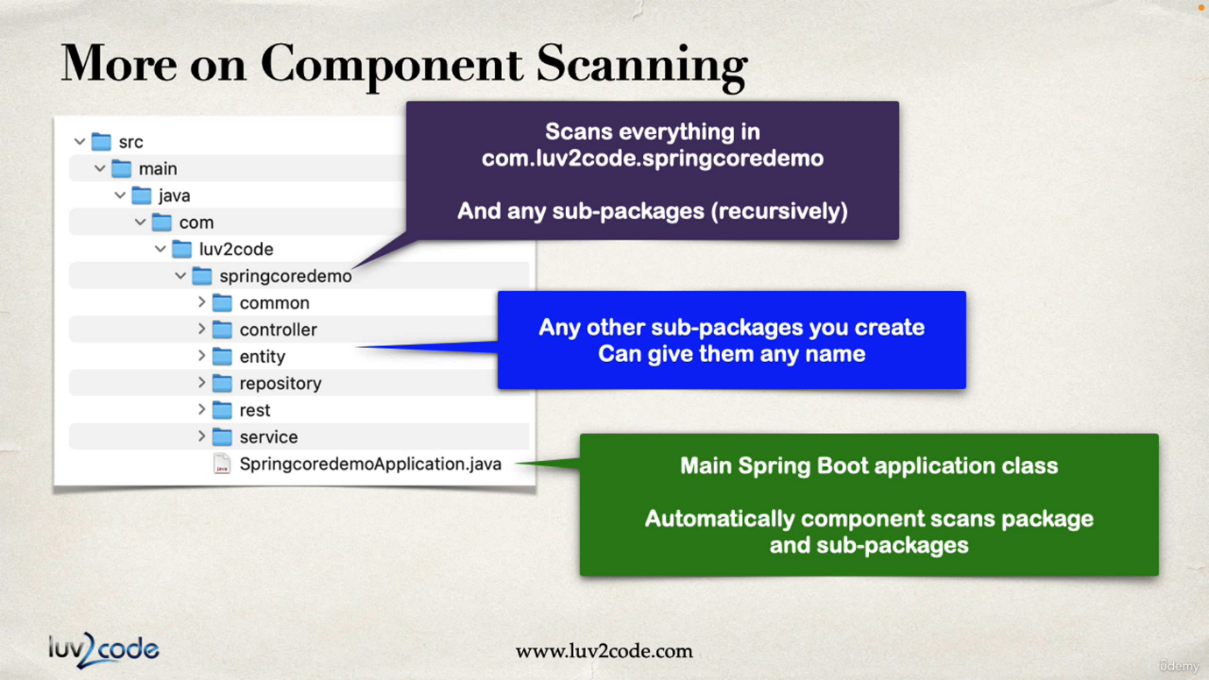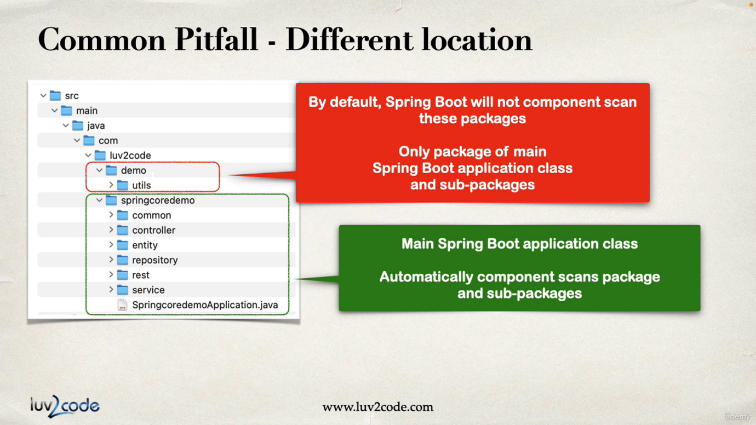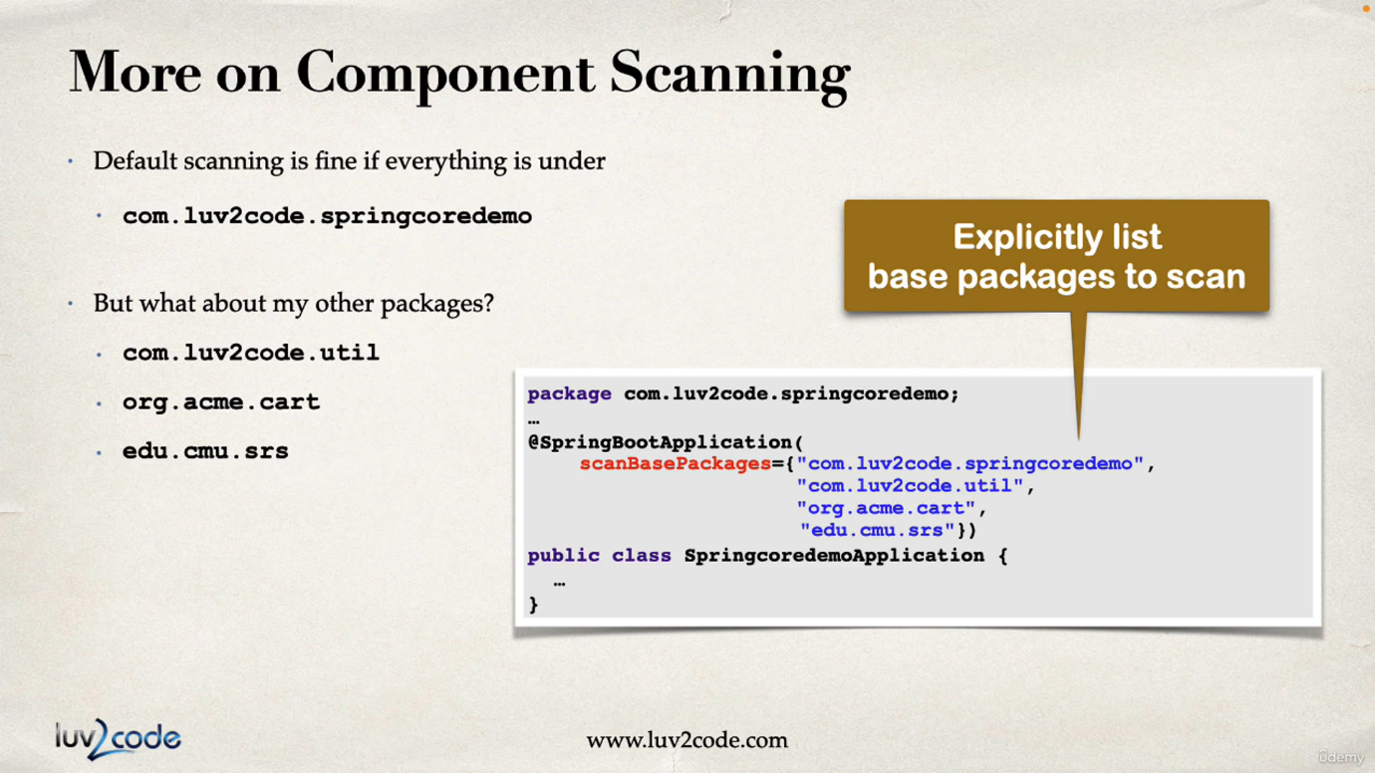

**Types of Dependency Injection**

1. **Field Injection –** We can perform Field injection by adding @Autowired above the declared field, where we are injecting the dependency

**Not recommended by spring.io**

Because it makes code harder to unit test

**Spring.io recommends constructor injection at first place or else setter injection**

@Autowired  
private Coach coach;

Coach here is an Interface so spring will find the classes that are implementing this interface and are beans(@Component), and inject the instance of that class into coach.

1. **Constructor Injection** – We can perform Constructor Injection by adding @Autowired above the constructor that sets the field.

**This is recommended by spring.io**

@Autowired //This is optional if we have only one constructor  
MyController(Coach coach) {  
 this.coach = coach;  
}

Spring behind the scenes performs this

*Coach coach = new CricketCoach();*

*MyController mycontroller = new MyController(coach);*

1. **Setter Injection** – We can perform setter injection by adding @Autowired above the setter of the field to which we are injecting.

We can call setter injection on any method not only on the setter. Just that the field should be set in that method along with dependency object as param to that function.

@Autowired  
public void setCoach(Coach coach) {  
 this.coach = coach;  
}

Spring behind the scenes performs this

*Coach coach = new TennisCoach();*

*MyController controller = new MyController();*

*controller.setCoach(coach);*

**@Qualifier** – This annotation is used to inject the specific bean.

When we are injecting a bean into an interface at that time there can be many beans that are implementing that interface so in this case there will be an ambiguity error hence, we can give the name of bean to inject that bean using Qualifier.

@Autowired  
MyController(@Qualifier("hockeyCoach") Coach coach, @Qualifier("cricket") Coach cricketCoach) {  
 this.coach = coach;  
 this.cricketCoach = cricketCoach;  
}

Here we are injecting coach with HockeyCoach class hence we have used “hockeyCoach” string. i.e. we should use same Class name as string with first letter smallcase. **CricketCoach -> “cricketCoach”, TennisCoach -> “tennisCoach”**

And we are injecting cricketCoach with CricketCoach class, but we have used “cricket” because in CricketCoach class we have given the name for bean using

**@Component(“cricket”)** like this we can give custom names for beans. And we cannot give same name.

**@Primary** – This annotation is used to make a bean primary, which is implementing a interface. Because that interface can be implemented by number of other classes and while autowiring this class is injected by default.

@Component("tennis")  
@Primary  
public class TennisCoach implements Coach {  
 public String workout() {  
 return "Hey I am Tennis Coach!!";  
 }  
}

Here TennisCoach is made primary bean.

@Autowired //This is optional if we have only one constructor  
MyController(@Qualifier("hockeyCoach") Coach hockeyCoach, @Qualifier("cricket") Coach cricketCoach, Coach coach) {  
 this.hockeyCoach = hockeyCoach;  
 this.cricketCoach = cricketCoach;  
 this.coach = coach;  
}

Here coach is having no Qualifier, so spring will inject the class that is implementing Coach interface but there are many classes that are implementing Coach interface. But TennisCoach is primary bean, hence this will be injected.

*There cannot be multiple Primary beans implementing same interface, it is an error.*

*If there is a Qualifier, then the Qualifier is given priority. Primary is only used when there is ambiguity.* ***Qualifier has higher priority than Primary.***

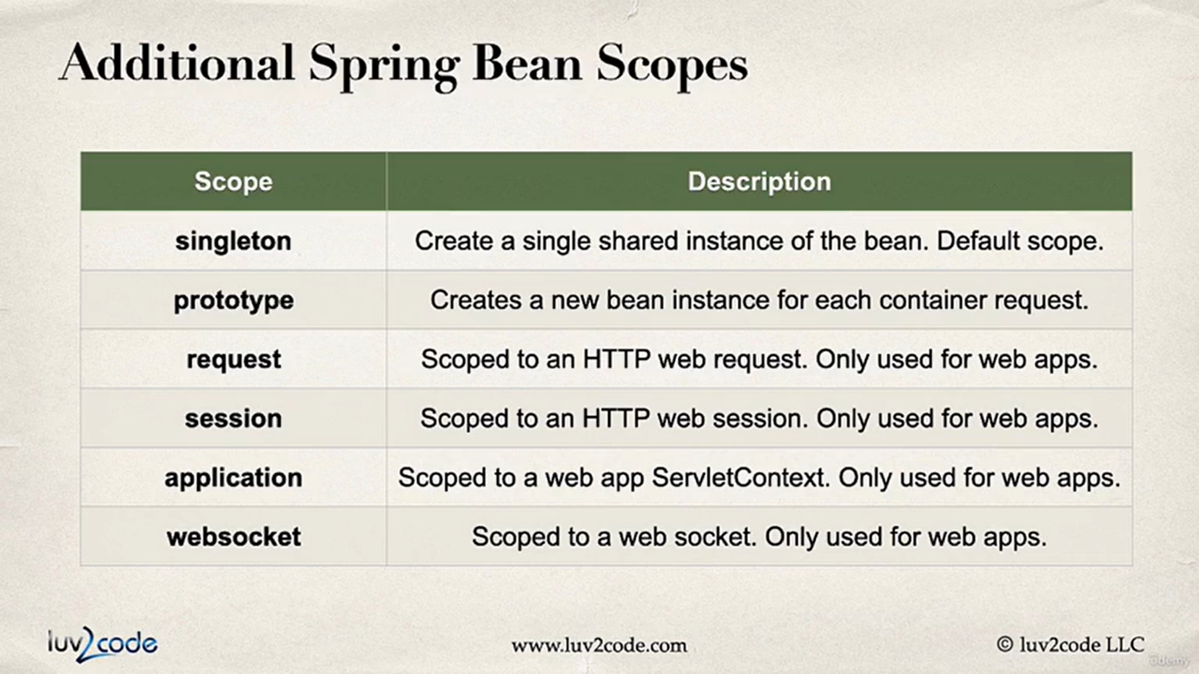

**Bean Lifecycle methods –**

We can define some methods which we can run on initialization or before destruction of a Bean.

**@PostConstruct –** Runs after constructor of a Bean.

**@PreDestroy –** Runs before the Bean is destroyed.

@PostConstruct  
public void postContruct() {  
 System.*out*.println("This is PostConstruct method of Life"); //This is called after constructor  
}  
@PreDestroy  
public void preDestroy() {  
 System.*out*.println("This is PreDestroy method of Life"); //This is called before the bean is destroyed  
}  
//NOTE: FOR PROTOTYPE SCOPE BEANS, SPRING DOES NOT DESTROY THE BEAN HENCE PreDestroy IS NOT CALLED.

**Java based Bean Configuration**

Instead of using annotations to mark a bean, we can do Bean configurations in two methods –

**1. XML based config** (Outdated)

**2. Java based config** (Recommended)

@Configuration  
public class CoachConfig {  
 @Bean  
 @Primary  
 public Coach cricketCoach() {  
 return new CricketCoach();  
 }  
  
 @Bean("football")  
 public Coach footballCoach() {  
 return new FootballCoach();  
 }  
}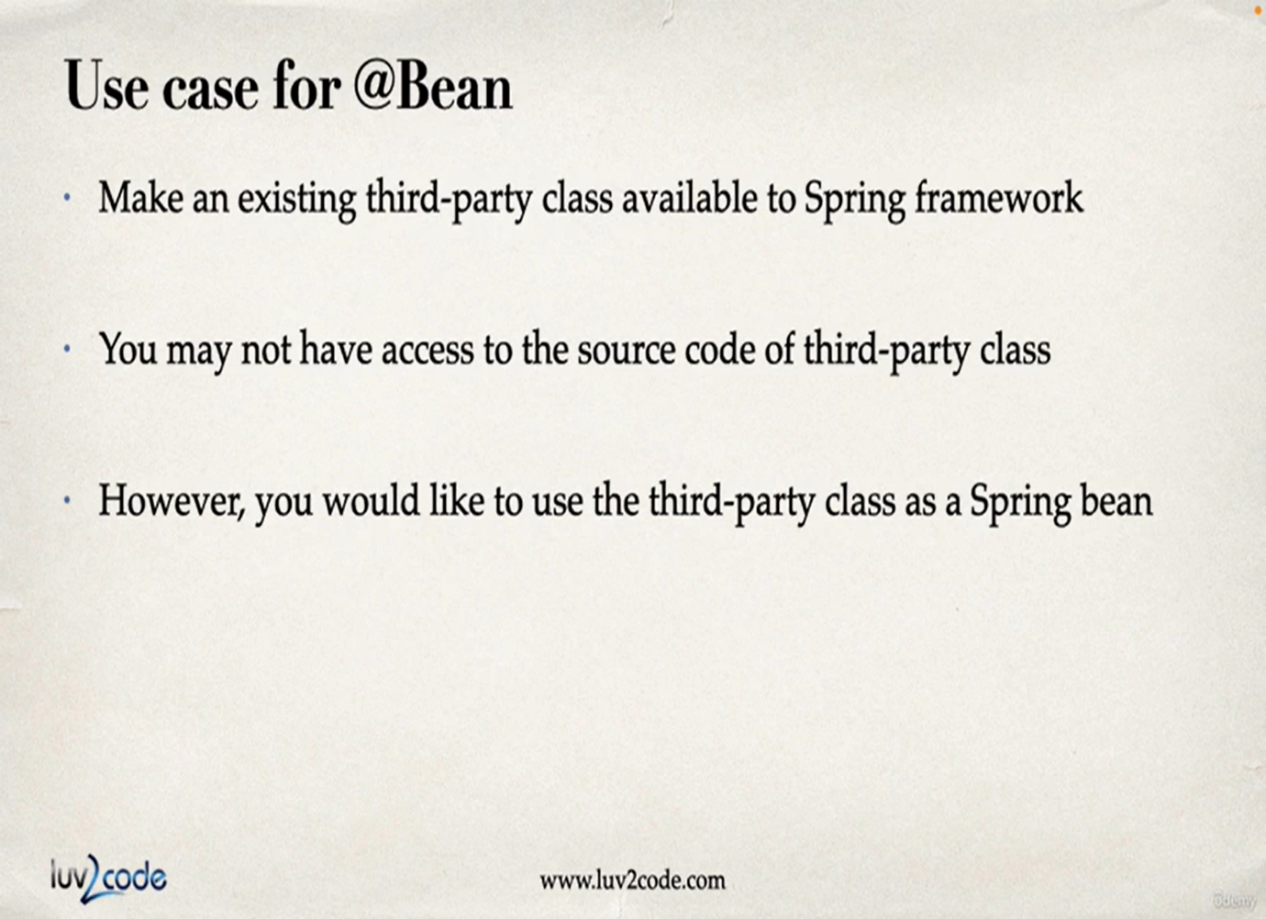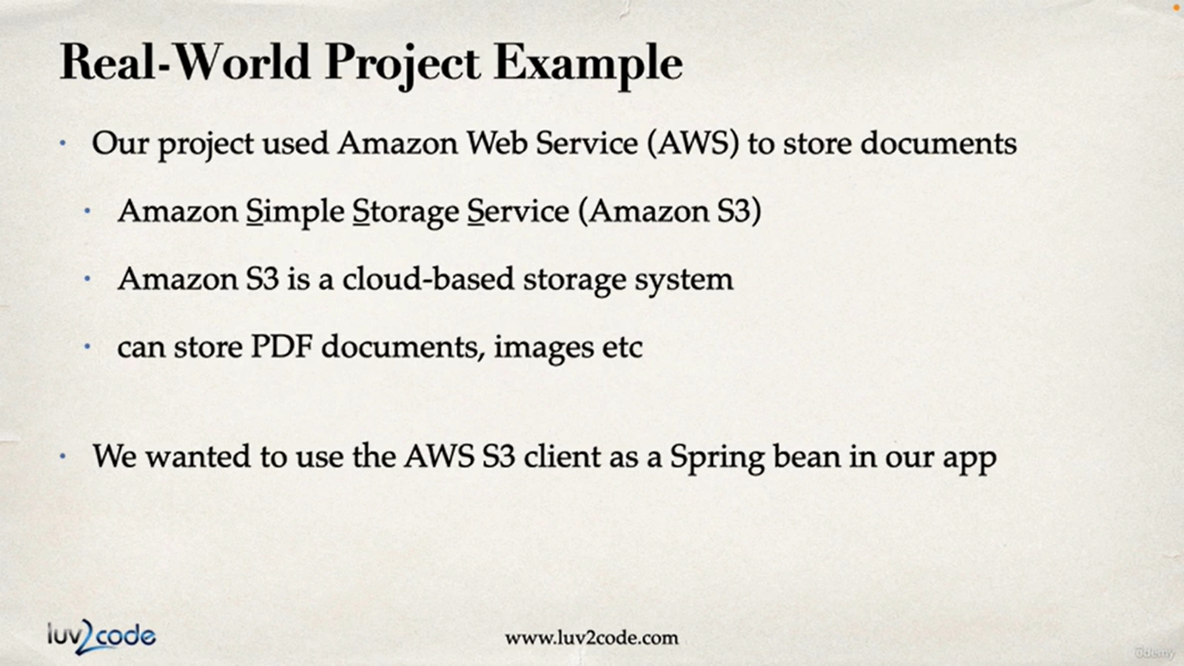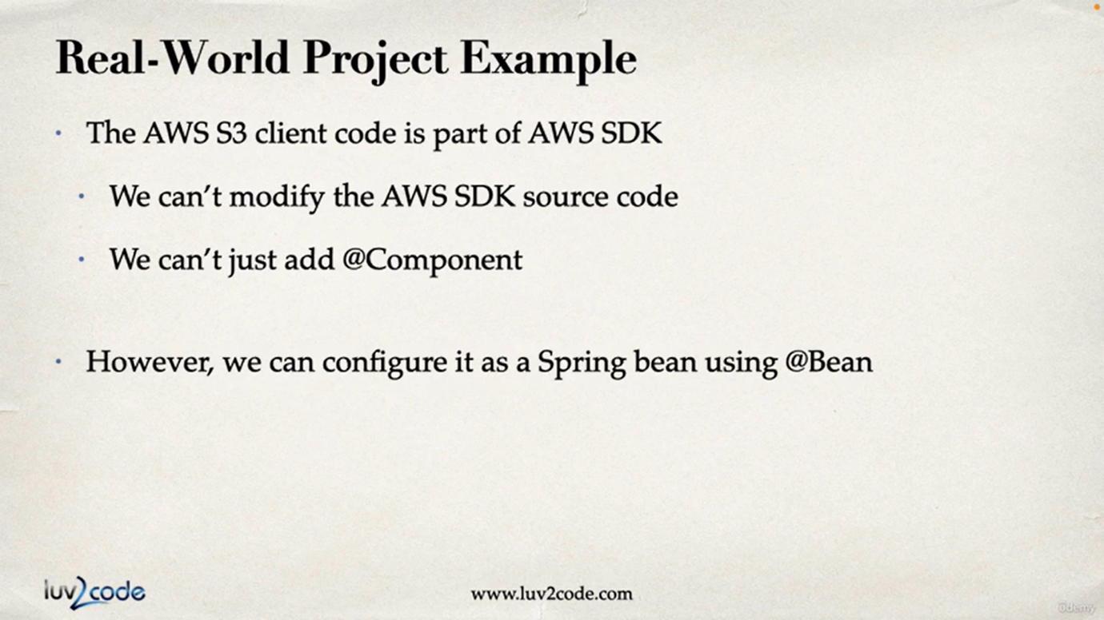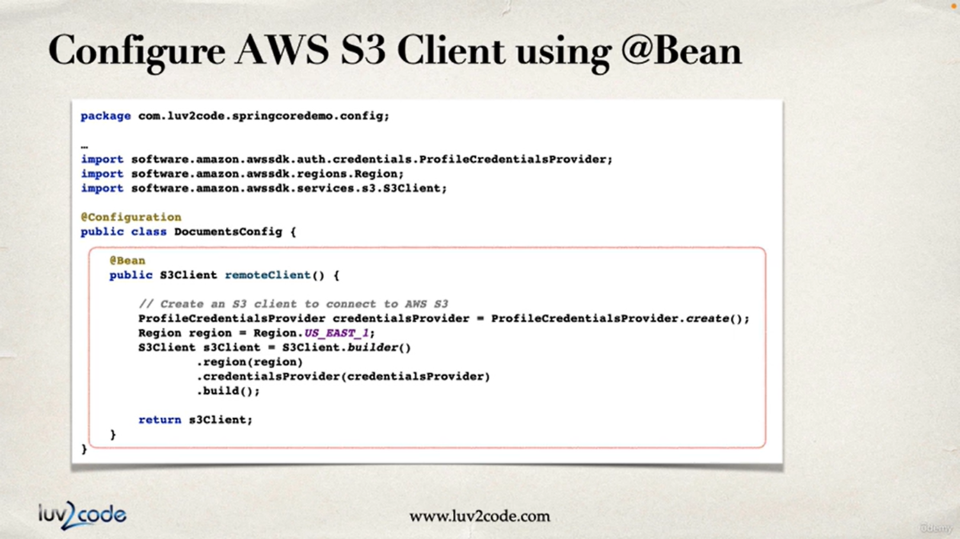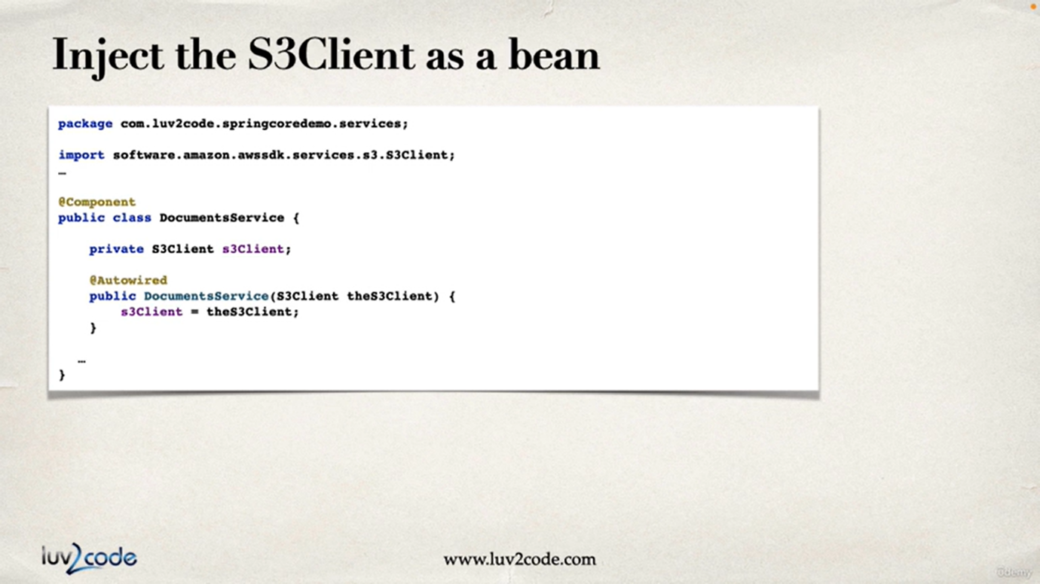

**@Component**

**@Service**

**@Entity**

**@RestController**

**@RequestMapping**

**@GetMapping, @PostMapping, @DeleteMapping, @PutMapping, @PatchMapping**

**@Autowire**

**@Primary**

**@Scope**

**@Qualifier**